Ellipsoidal wing summary

Geometry: The ellipsoidal wing is defined by the function

|  |  |  |
| --- | --- | --- |
|  | $$\frac{x^{2}}{a^{2}}+\frac{y^{2}}{b^{2}}+\frac{z^{2}}{c^{2}}=1$$ | (1) |

Where a=0.5, b=0.05 and c=1. This gives the following geometry

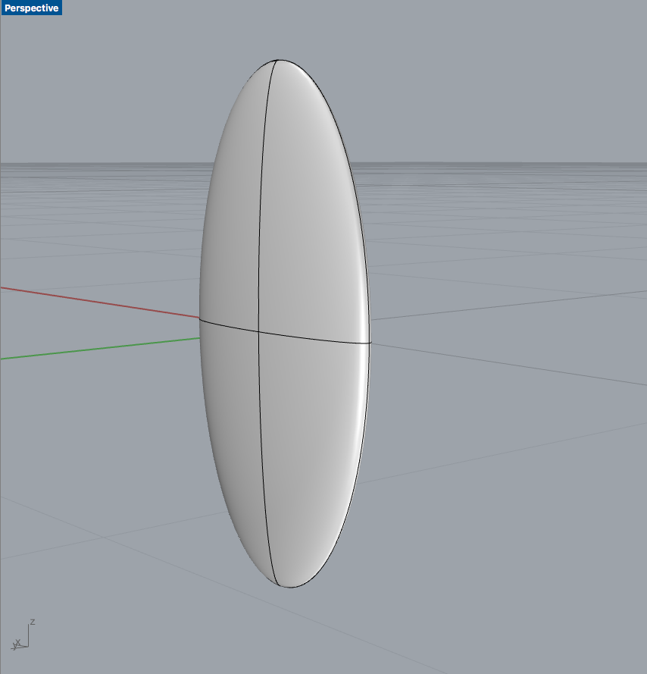

Kinematics:

The motion is completely described by the three following Euler angles

|  |  |  |  |  |
| --- | --- | --- | --- | --- |
|  | $$φ\left(t\right)=A_{φ}\cos\left(2πf_{r}t\right)$$ | | (2) | |
|  | $$θ\left(t\right)=A_{θ}\sin\left(2πf_{θ}t\right)$$ | (3) | |
|  | $$α\left(t\right)=\frac{π}{2}- A_{α}\cos\left(2πf_{r}t+ξ\right)$$ | (4) | |

A_i is the amplitude of the respective motion and f_r is the frequency of the stroke. For figure of O pattern f_\theta = 2f_r. (here we use f_\theta=f_=0.5, such that the stroke motion is confined into the x-z plane.). \xi is the deviation of the angle of attack to the stroke, it is set to zero in the following. The stoke amplitude A_\varphi=0.35\pi=63 degrees and A_\alpha=\pi/4=45 degrees.

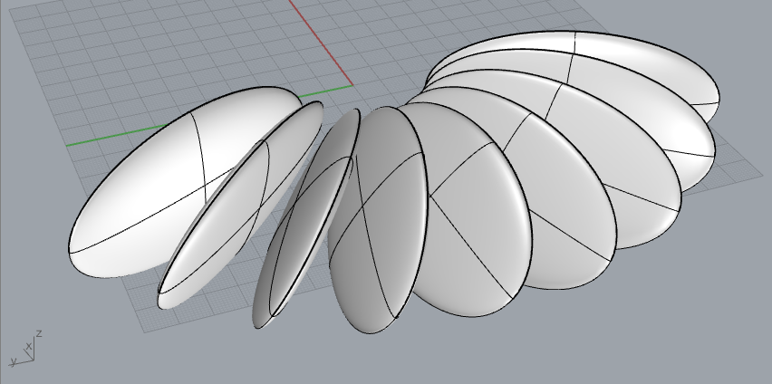

Results:

The wing is run in three different configurations: A thick ellipse, where the thickness is set to 0.25 (instead of 0.05), the standard ellipsoidal wing, as described above and a disk of constant thickness with the same planform as the ellipse. The runs with the modified kernel are denoted as “out-new-kernel-…”

Forces Coefficient: Below is the lift coefficient over a single period of motion. There are very large differences between the different methods used to defined the body. The thick body results in the lowest CL, this is expected as the wing is almost spherical. However, the stl and the standard case represent the same wing and the CL are very different. Results are almost identical when using eps=2 or eps=0.5. The magnitude of the spikes is clearly exaggerated when the geometry is defined using the squished sphere.

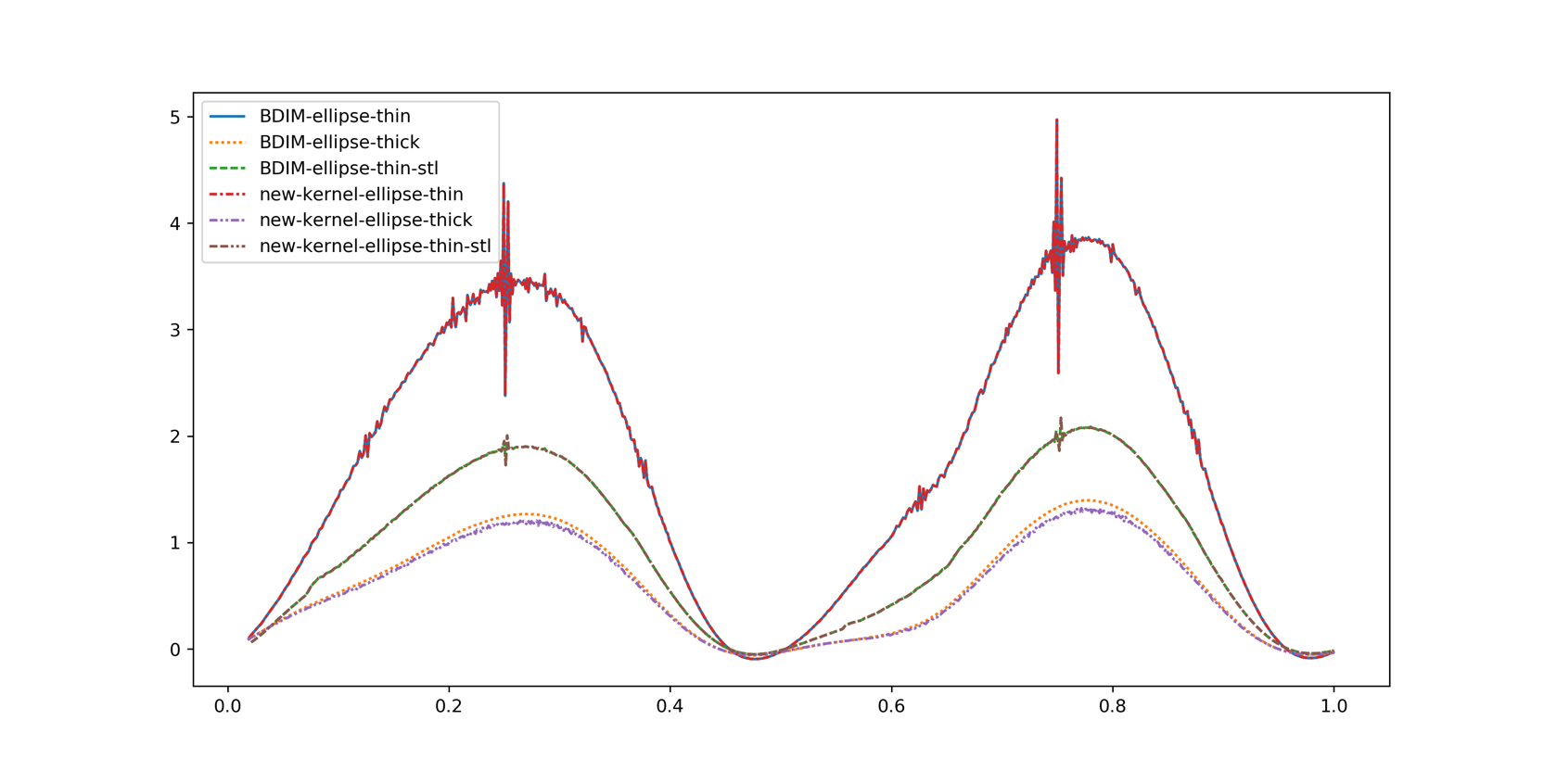

The CD shows similar behaviour, where spikes seems exaggerated when the geometry is defined using the squished sphere. Other than this, the CD magnitude between the eps=2 and eps=0.5 seems to be the same, with the largest difference when the geometry is defined as thick

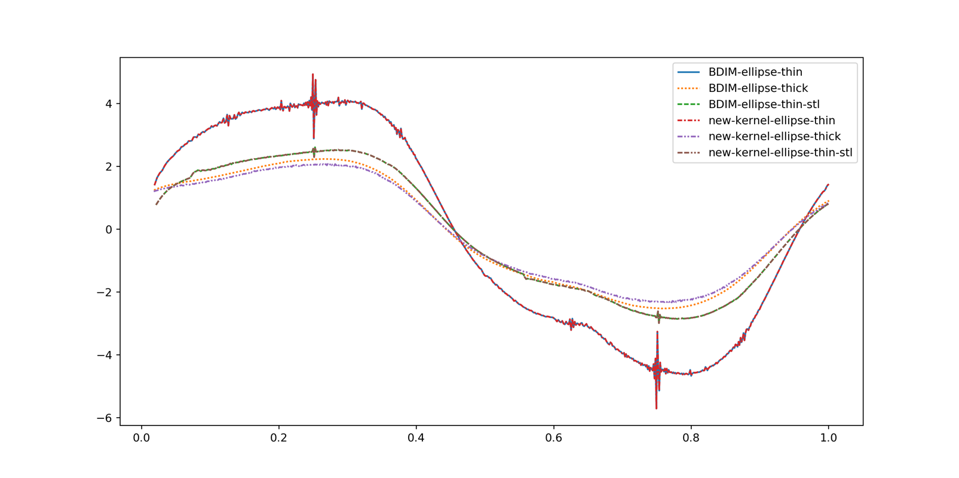

CFL values are also very similar, with only the one of the thick sphere being different.

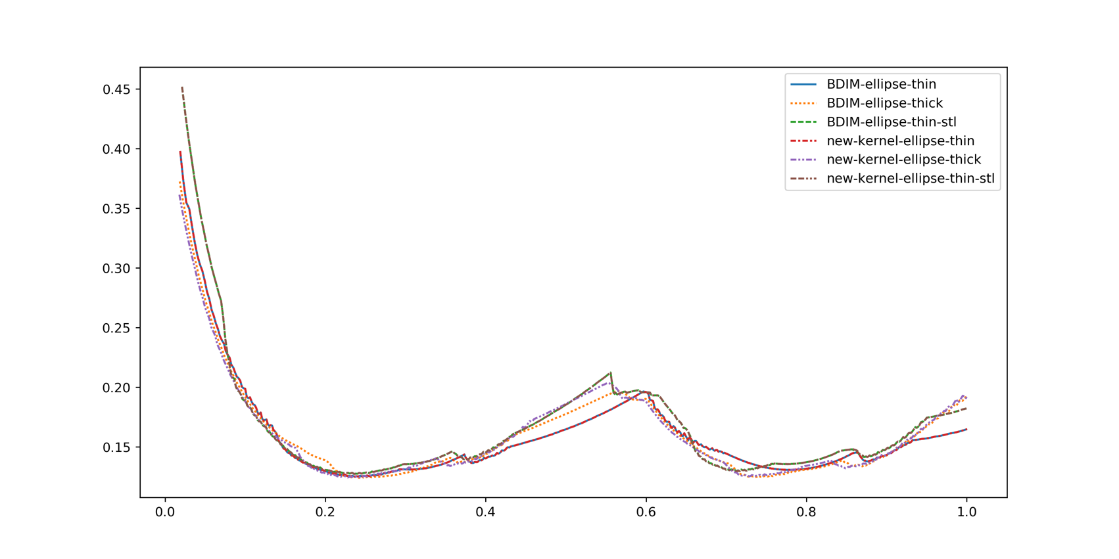

MultiGrid solver results:

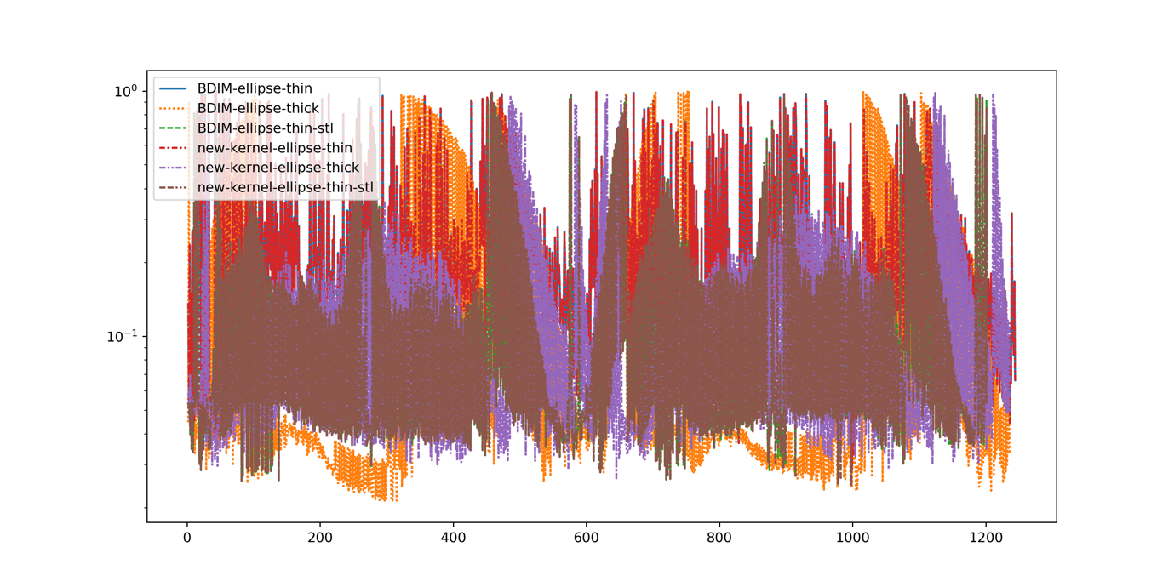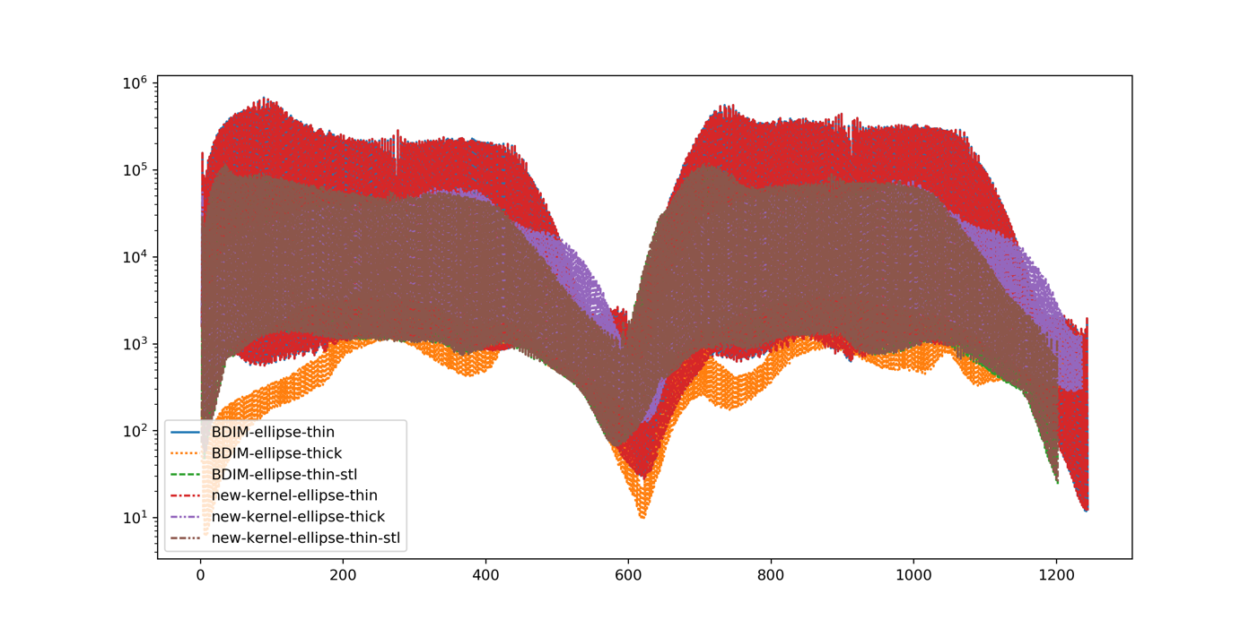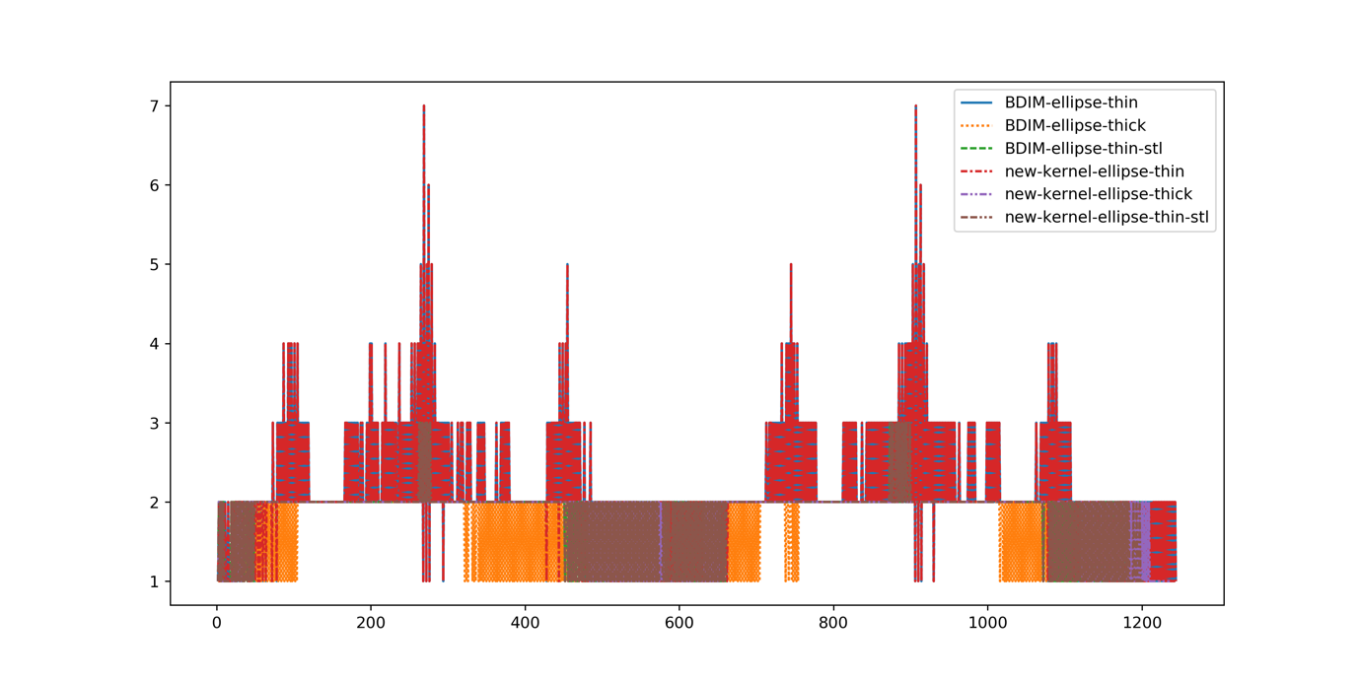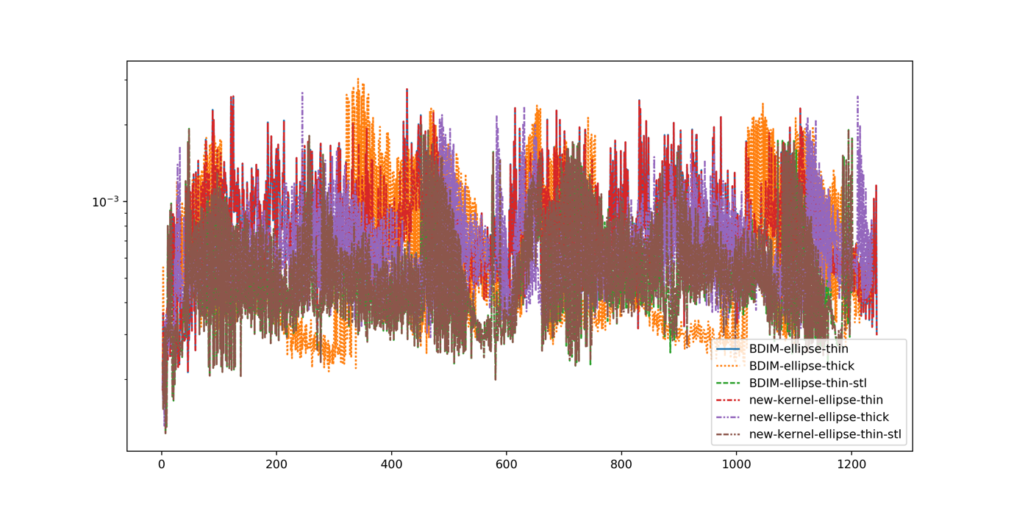

res

res0

itr

inf

Multi grid struggles most when the body is defined by the squished sphere. Peak of iteration is always at the same time, regardless of the method used and eps.

What is happening to the distance-function?

Distance function around the body, defined using the squished sphere (left), and the stl (right). The distance function is highly distorted in the case of the squished ellipse. I didn’t see that at first because I only looked at mu0, which are very similar, see below

body%dis

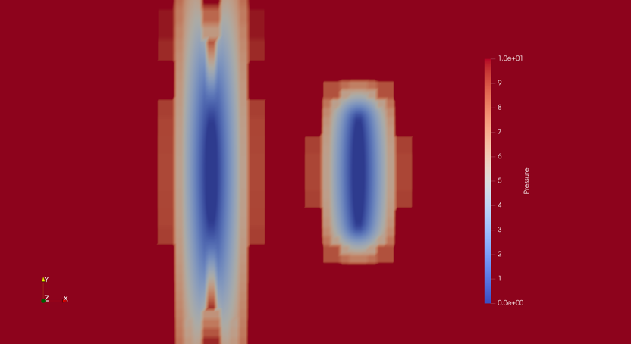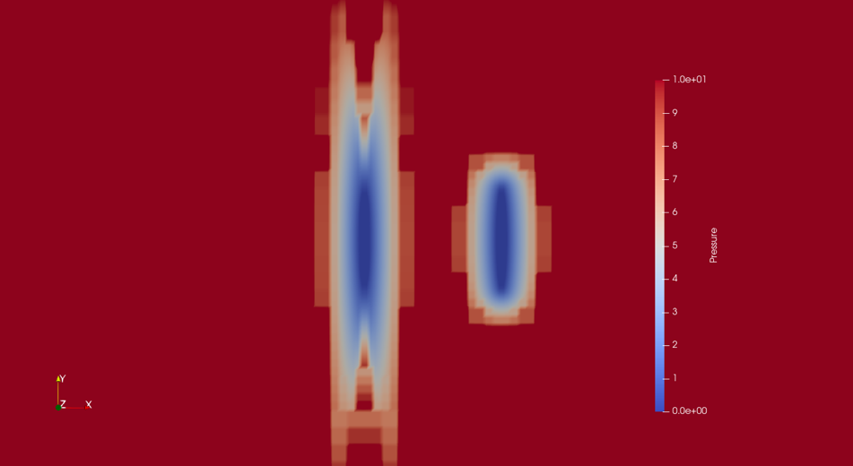

eps=0.5

eps=2.0

BDIM

New kernel

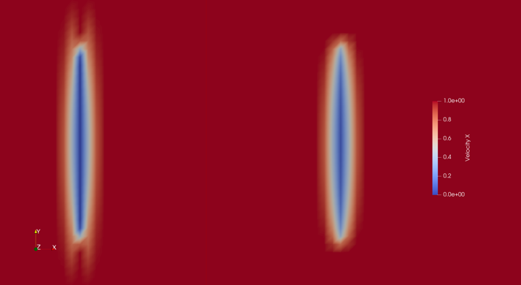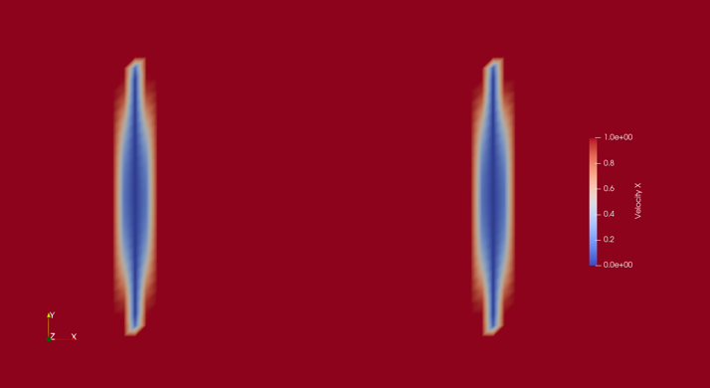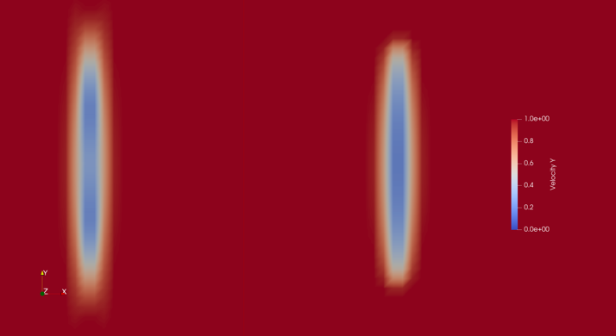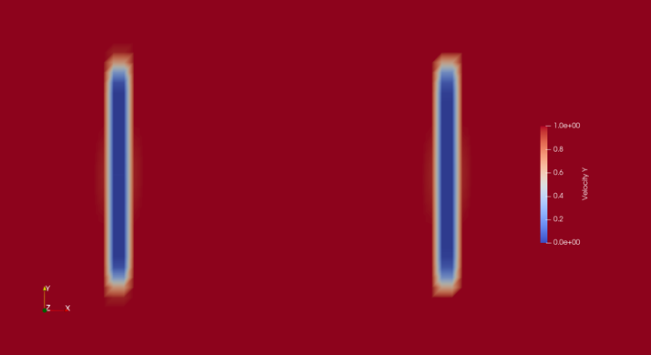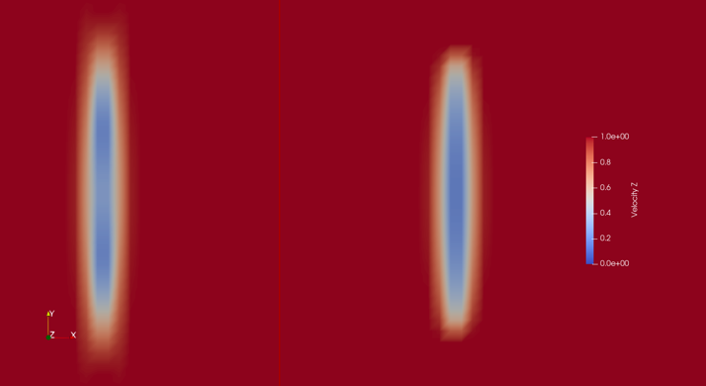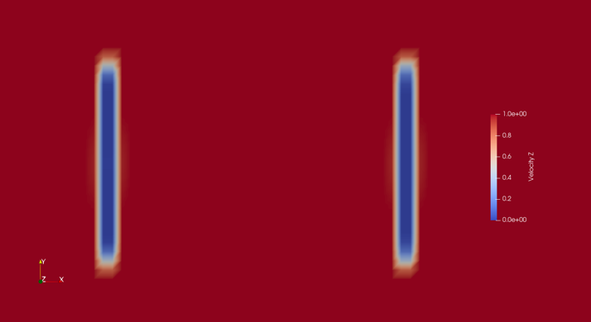

Flow%mu0

eps=2.0

eps=0.5

mu0_z

mu0_y

mu0_x

Mu0 is “fine” compared to the distance function, this is probably why the flow structure were very similar, regardless of eps, see below.

vortex core (lambda2=-0.005) at the end of the motion, the blue surface is using eps=2 and the red surface is using eps=0.5. The next plot is the difference between the two surfaces. The two flow are extremely similar.

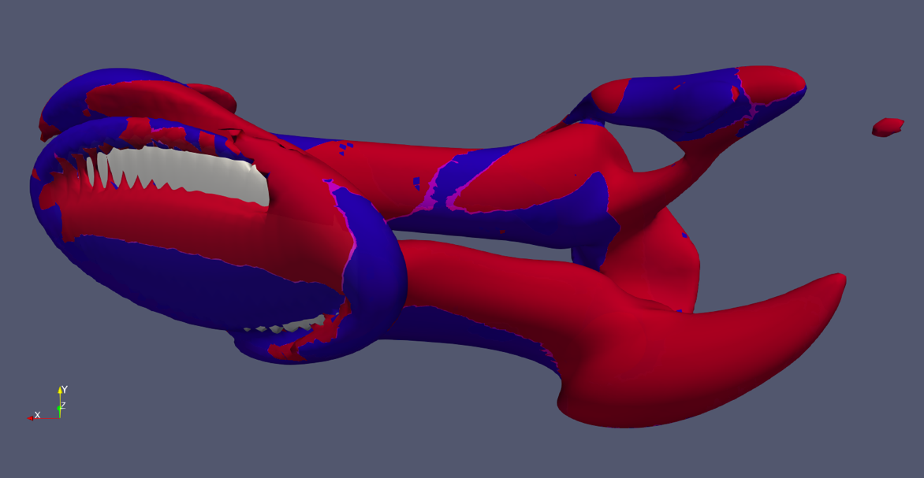

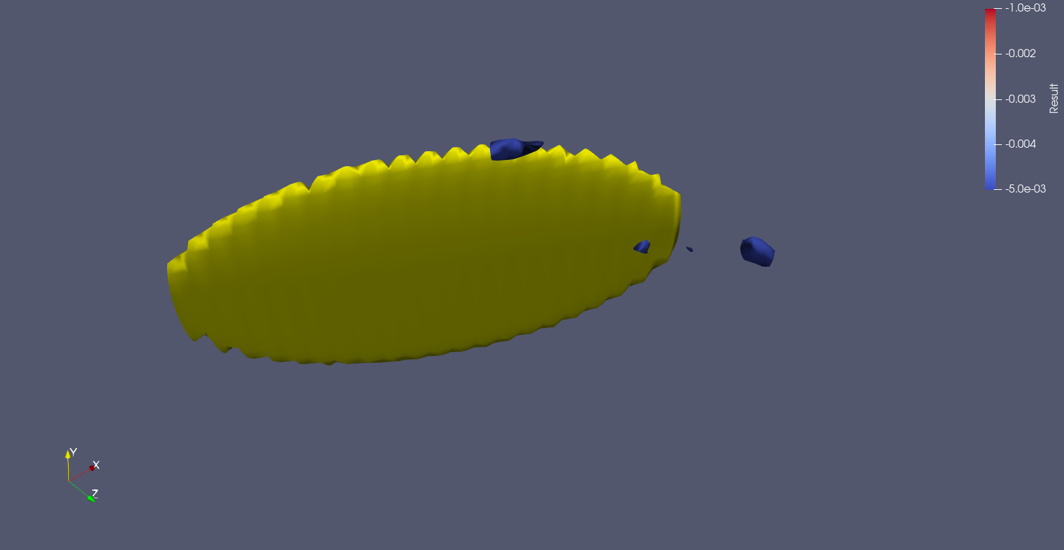

What is happening to the force integration kernel?

The contour plane is the x-y plane (z-normal, same as before)

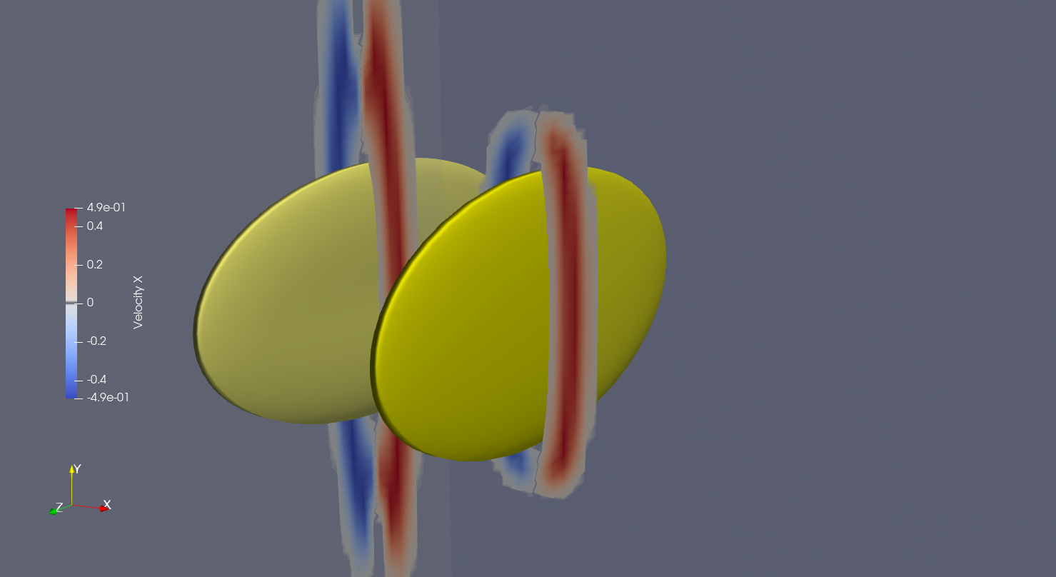

The force integration kernels are the same, as eps is only adjusted for the body moment contribution in the NS. With the distorted distance function, the force integration kernel is sampling very far from the body, and on a much bigger area that it should be. The body defined using the stl has the correct behaviour. This is probably why the force from the squished sphere seem to be a scaled version of the force form the stl, and potentially the source of some of the oscillations, from sampling too far into the shear layer on the edge of the wing

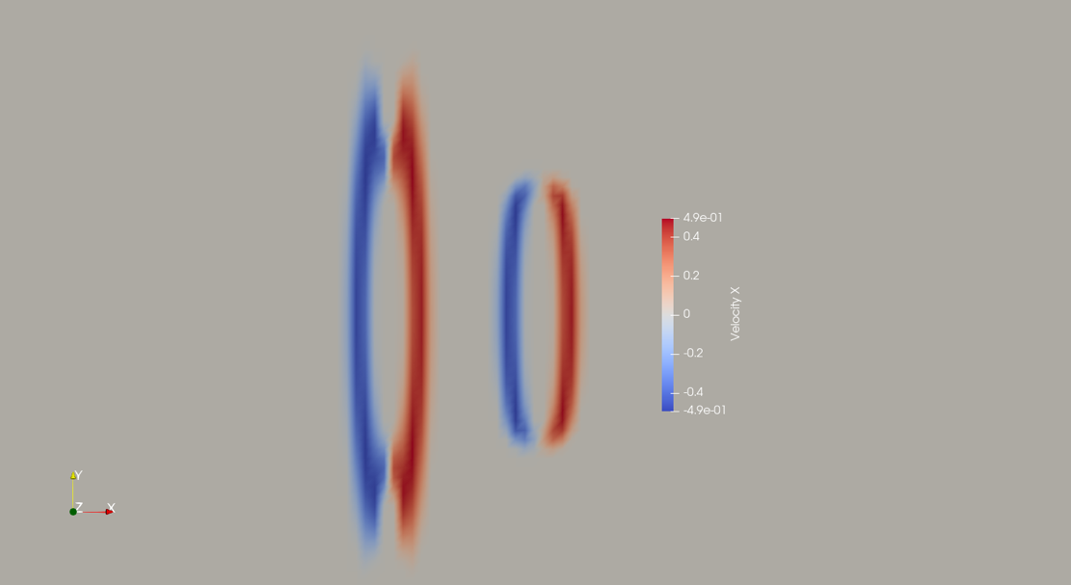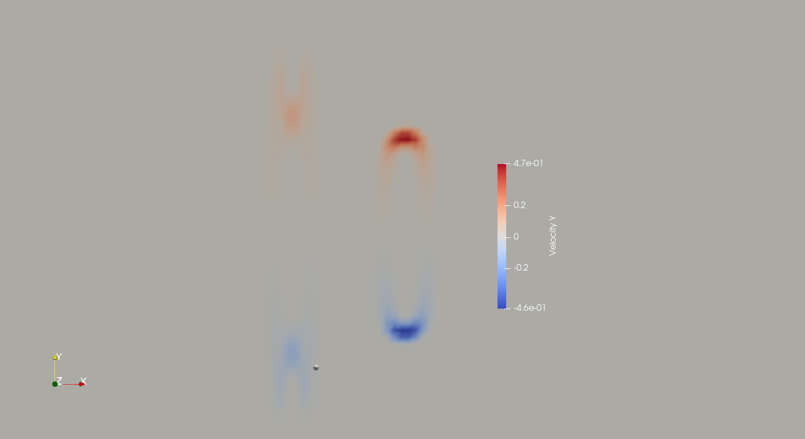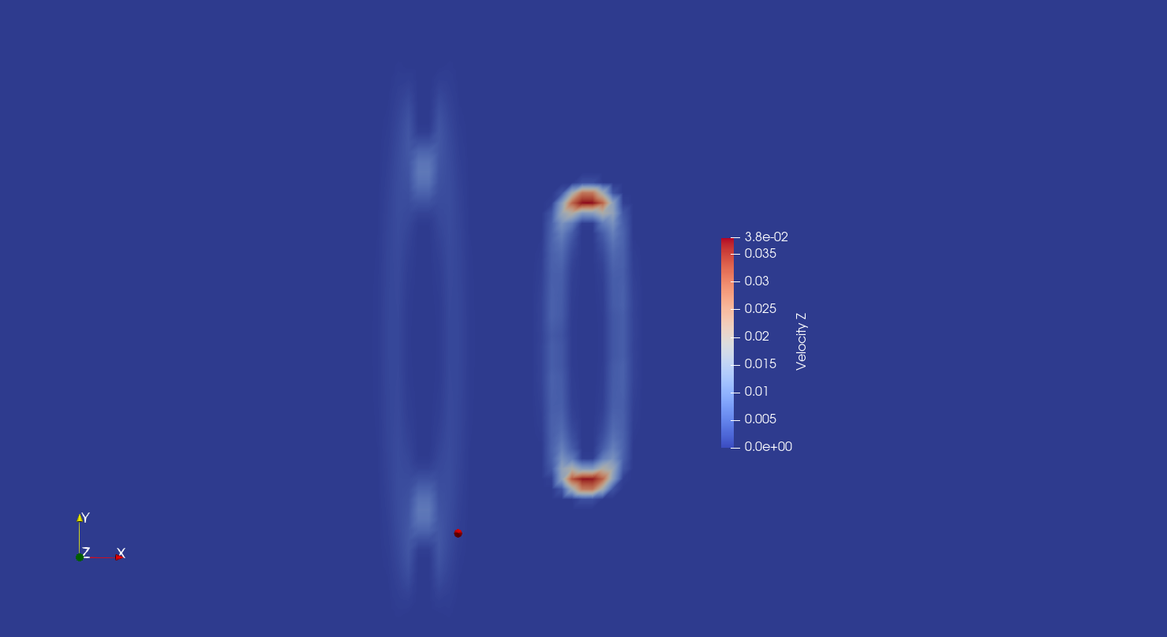

Kernel_z

Kernel_y

Kernel_x

Conclusion:

* the flow seems alright, it seems to be an artefact for the force integration kernel that is not right. However, there were some oscillations in the force on the thick ellipse, when eps=0.5 as well that where not present with eps=2. So eps surely has something to do with oscillations, but maybe not as much as I thought.
* Also, this doesn’t explain the peak that we see in the forces when defined using the stl. Reducing the resolution from C=48 to C=32 does not change the results.
* The runs with the disk, to avoid having to define a stl geometry or a squished sphere here the thickness is set to the minimum value possible, so dr=1+sqrt(3) for the new-kernel and dr=5 for the standard BDIM kernel. CL is much high for new kernel and has some oscillations that are not present in the BDIM case. Epsilon definitely has something to do with oscillations

